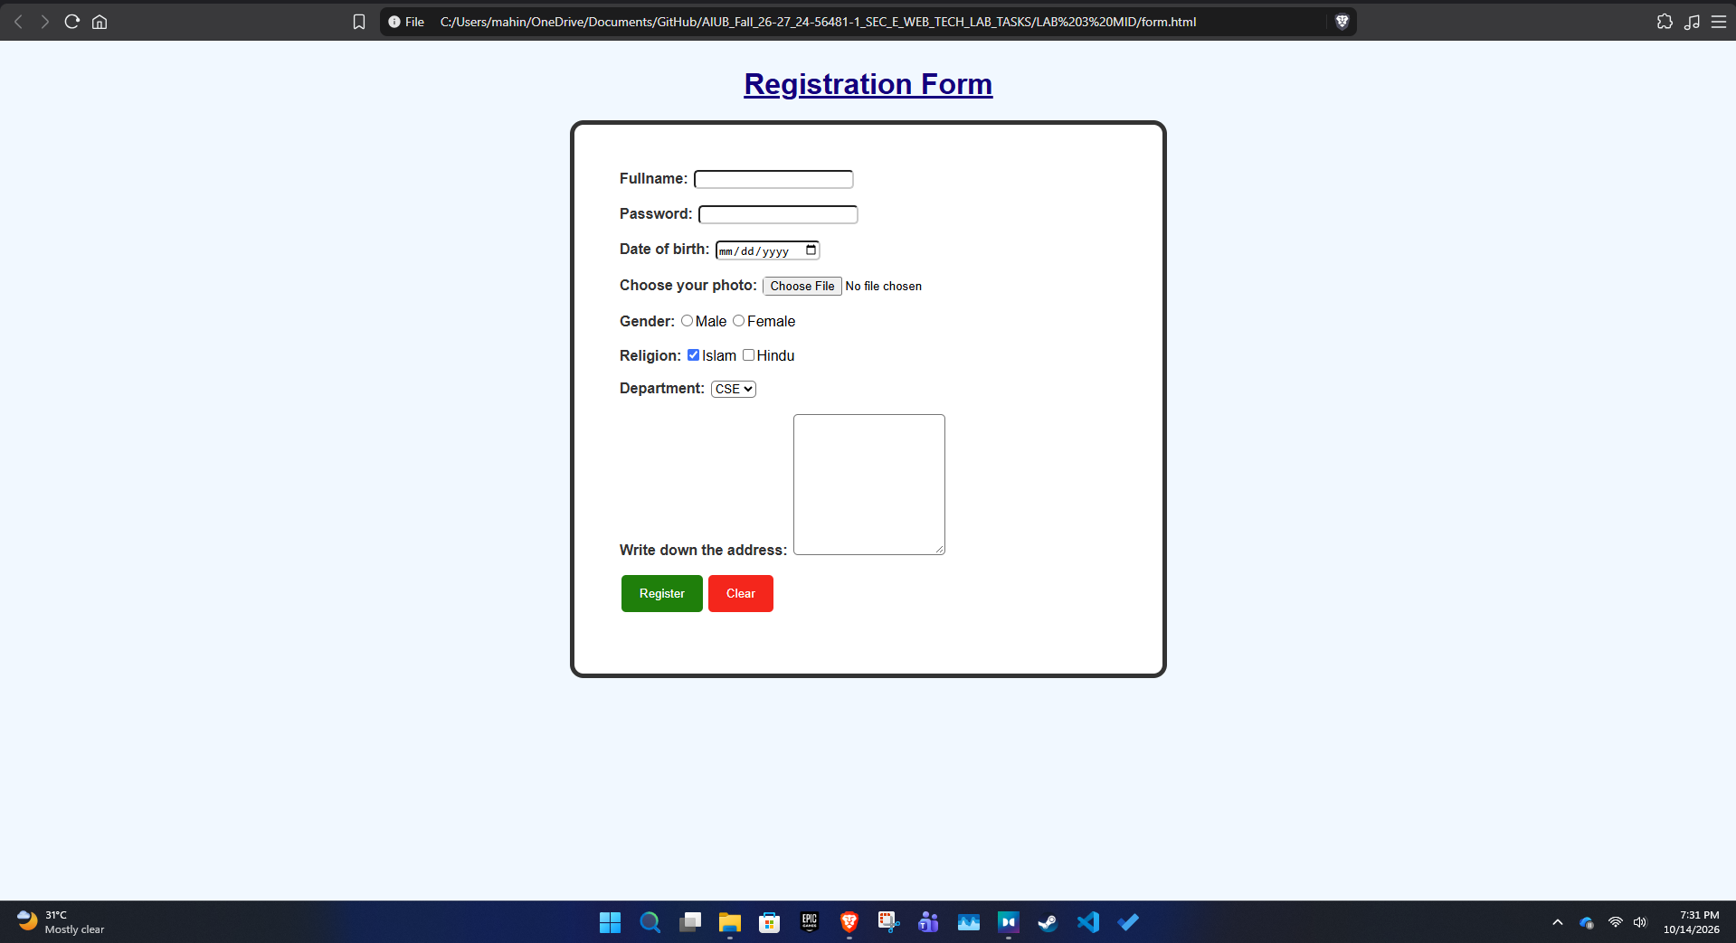
FIGURE OF REGISTRATION FORM

